**JOB DESCRIPTION**

**TITLE:**  Lawyer

**REPORTS TO:** Senior Lawyer based in Cardiff

**LOCATION:** Cardiff although some homeworking will be possible

**GRADE:** 13

**SALARY:** £44,340 per annum pro rata

**CONTRACT:** 0.6 FTE, Fixed Term until 31/03/2022

**PURPOSE**

**The IOPC’s Legal Services is headed by IOPC General Counsel and reports to the Deputy Director General Corporate Services. Our lawyers play an active and important role in all of the organisation’s work. They advise colleagues in our Operations Directorate in relation to the exercise of their powers and police misconduct decision-making. They also represent the IOPC in legal proceedings (e.g. judicial review, inquests and police misconduct proceedings). They advise colleagues in the Strategy and Impact Directorate contributing to the development of organisational policy. Much of our work is high profile and lawyers are often called upon for advice on extremely sensitive matters which are subject to intense media scrutiny.**

**KEY RELATIONSHIPS**

**The post holder will work closely with clients across the IOPC including senior clients such as the Director General, Deputy DG Operations and Deputy DG Corporate Services, Regional and Executive Directors and Heads of Function. S/he will also be expected to develop professional working relationships with solicitors acting for complainants, police forces, legally qualified chairs and individual officers and members of police staff, internal and external stakeholders at all levels but particularly with the Senior Information Risk Owner (SIRO), the Information Asset Owners (IAO’s), the IOPC Facilities Management (FM) team, the external accreditor, staff of outsourced suppliers and Home Office and CESG representatives.**

**The post holder will be security cleared to Standard DBS (Disclosure and Barring Service).**

# ORGANISATIONAL CONTEXT

# 

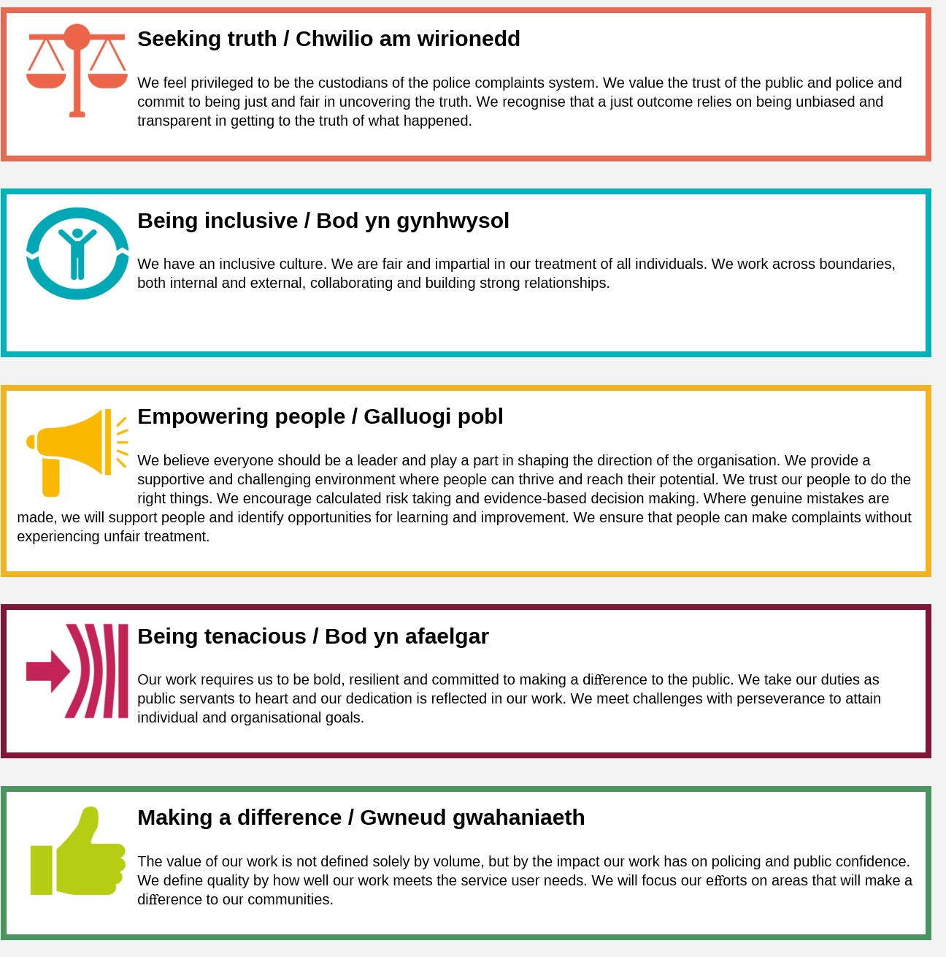We work in the context of our agreed values which inform the way we do things at the IOPC. The **Lawyer** will need to be commited to managing in the context of these values.

**MAIN DUTIES AND RESPONSIBILITIES**

* **To provide advice to organisation staff on all areas of the organisation’s work including casework, investigations and policy.**
* **To handle a caseload of matters including litigation cases, inquests, judicial review cases and misconduct hearings.**
* **To undertake advocacy.**
* **To participate in the development and review of organisational policy.**
* **To participate in service wide initiatives and projects.**
* **To lead on certain allocated legal issues.**
* **To comply with the Legal Service’s policies and procedures.**
* **To comply with all relevant corporate policies and procedures.**
* **Must be prepared to travel to attend hearings or other IOPC offices if necessary, (Additional travel costs will be paid for by the IOPC) in particular: .**
  + **if based in the South East – Canary Wharf and Croydon offices;**
  + **if based in Sale, then travel to the Wakefield office;**
  + **if based in Birmingham, then travel to Cardiff office.**
* **To undertake other duties commensurate with the level and remit of the post as may time to time be allocated by the General Counsel or another member of the Legal Services Senior Management Team.**
* **After 6 months of employment to provide telephone based on-call cover. This is on a rota within the Legal Team and is approximately 2-3 weeks per year. Additional on-call allowances are payable.**

**PERSON SPECIFICATION**

**Essential**

* **Qualified solicitor or barrister entitled to practice in England and Wales.**
* **Post qualification experience in at least one relevant areas of law – these include criminal law, police law, coronial law, public and administrative law and human rights law.**
* **Experience of advising on complex issues.**
* **Experience of handling substantial and complex cases.**
* **Strong analytical skills with the ability to master new material rapidly.**
* **Excellent oral and written communication skills.**
* **Problem solving skills.**
* **Approachable and constructive.**
* **A good team worker but also able to work independently.**

**Desirable**

* Experience of litigation
* Knowledge of FoI and DPA matters
* Knowledge of complaints systems and handling

**Selection process**

This vacancy is using [**Success Profiles**](https://www.gov.uk/government/publications/success-profiles?_ga=2.156185915.1692943174.1578577916-319911383.1576576754). As part of the application process you will be asked to complete four sift stage questions.

The Behaviours being assessed are:

* Communicating and Influencing
* Managing a Quality Service
* Delivering at Pace

For successful candidates who reach the assessment stage, we will provide further details of what will be assessed.

**What is Success Profiles?**

Success Profiles moves us to a tailored way of assessing, dependent on the requirements of the job. For each role we advertise, we consider what you will need to demonstrate in order to be successful. This gives us the best possible chance of finding the right person for the job, drives up performance and improves diversity and inclusivity so that we can truly reflect the communities that we serve.

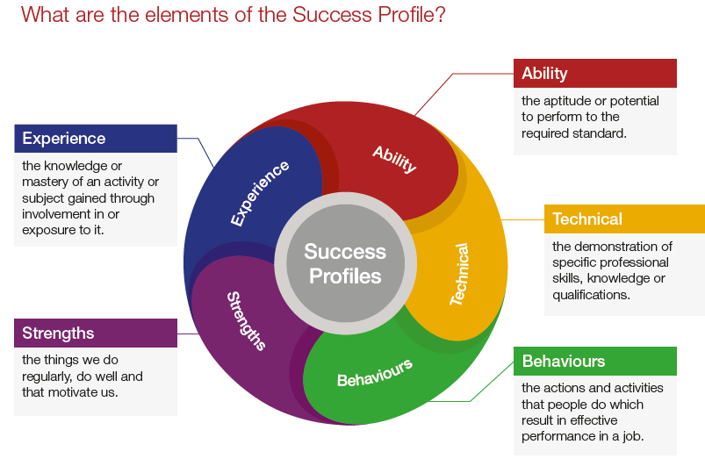Not all of the elements are relevant to every role, and will vary depending on the level and type of role. You should ensure you read the job description carefully to see what elements are required for the specific job you are applying for. There are separate guides to each of the elements, which will give you more information about what and how you can demonstrate specific requirements.

**How the elements are assessed**

You could be assessed in a number of different ways, depending on the type of role and level you are applying for. Using a range of assessment methods helps us to more accurately match people to the essential requirements of the job. For example, you may be asked to complete an application form; provide a CV and supporting statement; attend an assessment centre; or complete an online test. Often a combination of these approaches will be used and more than one element may be tested within the same assessment method.

Details of which elements will be assessed and how we will assess you against these, are included in the job description.

**Reasonable adjustments**

The IOPC is a diverse and inclusive workplace and we want to help you demonstrate your full potential whatever type of assessment is used. If you require any reasonable adjustments to our recruitment process please contact [humanresources@policeconduct.gov.uk](mailto:humanresources@policeconduct.gov.uk)

**Preparation checklist**

Review the full job description ☐

Review the behaviours and the descriptors for each behaviour☐

Review the Strengths dictionary ☐

Review the IOPC values ☐

Consider your Strengths (if applicable) ☐

Consider drafting example answers that cover the specific elements ☐

Prepare some questions to ask the interviewers ☐